**Chapter – 1**

**HTML Overview**

**HTML**

**HTML stands for hypertext markup language**

* **Language :-** Languages are used to communicate from one person to another person.
* **Name of some languages :-** English , Hindi , Tamil etc .
* **Levels of computer languages** 
  + Low level or machine language
  + Middle level or assembly language
  + High level language
* **Low level or machine language**

Low level language written in binary number that means 0 and 1 used to develop an operating system for particular machine. Ex-

8B542408 83FA0077 06B80000 0000C383 FA027706 B8010000 00C353BB 01000000 B9010000 008D0419 83FA0376 078BD989 C14AEBF1 5BC3

* **Middle level or assembly language**

Middle level language written in english and it contains assembler to translate english code in binary that means machine language used to develop an operating system for particular machine. Ex-

fib: mov edx, [esp+8] cmp edx, 0 ja @f mov eax, 0 ret @@: cmp edx, 2 ja @f mov eax, 1 ret @@: push ebx mov ebx, 1 mov ecx, 1 @@: lea eax, [ebx+ecx] cmp edx, 3 jbe @f mov ebx, ecx mov ecx, eax dec edx jmp @b @@: pop ebx ret

* **High level language**

High level language written in english and it contains compiler and interpriter to translate english code in binary that means machine language used to develop an application softwares. ex-

unsigned int fib(unsigned int n)

{

if (n <= 0)

return 0;

else if (n <= 2) return 1;

else { unsigned int a,b,c; a = 1; b = 1; while (1) { c = a + b; if (n <= 3)

return c;

a = b;

b = c; n--;

}

}

* **About HTML**

HTML stands for Hypertext Markup Language, and it is the most widely used language to write Web Pages. As its name suggests, HTML is a Markup Language which means you use HTML . to simply "mark-up" a text document with tags that tell a Web browser how to structure it to display.

**Chapter - 2**

**HTML Tags**

**HTML**

**HTML stands for hypertext markup language**

* **About HTML**

HTML stands for Hypertext Markup Language, and it is the most widely used language to write Web Pages. As its name suggests, HTML is a Markup Language which means you use HTML . to simply "mark-up" a text document with tags that tell a Web browser how to structure it to display.

* **What is tag ?**

A text surrounded by angle brackets is known as tags ex- <stpce>

**More concepts about tags**

|  |  |
| --- | --- |
| **Text** | **Tags** |
| html | <html> |
| body | <body> |

* **Use of tags**

Tags are used to display our contents on webpage and it also defines the place of our contents .

* **Important topics about tags.**

1. A tag starts with <> bricket and closed with </> Ex- <html> </html>
2. A start tag also called opening tag and closed tag also called closing tag .
3. tag must be closed with </> brickets
4. A tag marked our content to display them on webpage . Ex- <html> our content </html>

**Chapter 3**

**HTML Versions & Element**

**HTML**

HTML stands for hypertext markup language

HTML ( Hyper text markup language ) is Developed by Team Berners-Lee

|  |  |
| --- | --- |
| VERSIONS | YEAR |
| HTML | 1991 |
| HTML 2.0 | 1995 |
| HTML 3.2 | 1997 |
| HTML 4.01 | 1999 |
| XHTML | 2000 |
| HTML5 | 2014 |

**HTML ELEMENTS**

An html element must have <starting tag>contents</closing tag>

Example : -

<body> : **starting tag**

My name is amit : **contents**

</body> : **closing tag**

**Chapter - 4**

**HTML DOCTYPE DECLARATIONS**

**& TYPOGRAPHY TAGS**

**HTML**

HTML stands for hypertext markup language

**Doctype Declarations**

Doctype declaration is a comment that tells in which version of HTML coding is done. The doctype declaration tells our web server that we are coding in HTML.

**Types of Doctype Declaration**

1. HTML 4.01
2. XHTML
3. HTML5
4. **HTML 4.01 Doctype Declaration Syntax :-** <!DOCTYPE HTML PUBLIC "//W3C//DTDHTML4.01Transitional//EN""http://www.w3.org/TR/html4/loose.dtd">
5. **XHTML & HTML 4.01 Doctype Declaration Syntax :-** <!DOCTYPE HTML PUBLIC "-//W3C//DTD HTML 4.01//EN" "http://www.w3.org/TR/html4/strict.dtd">
6. **HTML 5 Doctype Declaration Syntax :-** <!DOCTYPE html> And <!doctype html>

**Note:-**

* Always you have to do doctype declaration in html 5
* If you do the doctype declaration in html5 version then you can take advantage of all the features of HTML 4 and XHTML.

HTML 4 basic Structure in HTML 5 Doctype Declaration.

<!DOCTYPE html>

<html>

<head>

<title> Write Title Content Here </title>

</head>

<body> Write Body Content Here </body>

</html>

**Typography tags**

**Heading text tags**

<h1> STP COMPUTER EDUCATION </h1>

<h2> STP COMPUTER EDUCATION </h2>

<h3> STP COMPUTER EDUCATION </h3>

<h4> STP COMPUTER EDUCATION </h4>

<h5> STP COMPUTER EDUCATION </h5>

<h6> STP COMPUTER EDUCATION </h6>

**Paragraph text tags**

<p>welcome to stp computer education</p>

**Centered text tags**

<center>Center Content write Here </center>

**Moving text tags**

<marquee>Moving Content Write Here</marquee>

**Chapter – 5**

**TASK**

<!DOCTYPE html>

<html>

    <head>

        <title>

            stpce

        </title>

    </head>

    <body>

        <h1>STP Computer Education</h1>

        <hr>

        <h2>STP Computer Education</h2>

        <hr>

        <h3>STP Computer Education</h3>

        <hr>

        <h4>STP Computer Education</h4>

        <hr>

        <h5>STP Computer Education</h5>

        <hr>

        <h6>STP Computer Education</h6>

        <hr>

        <u><b>I'm the student of STP COMPUTER EDUCATION</b></u>

        <marquee><h1>WELCOME TO MY PLACE</h1></marquee>

        <br>

        <hr>

        <pre>i'm in left                                                                             i'm in right</pre>

    </body>

</html>

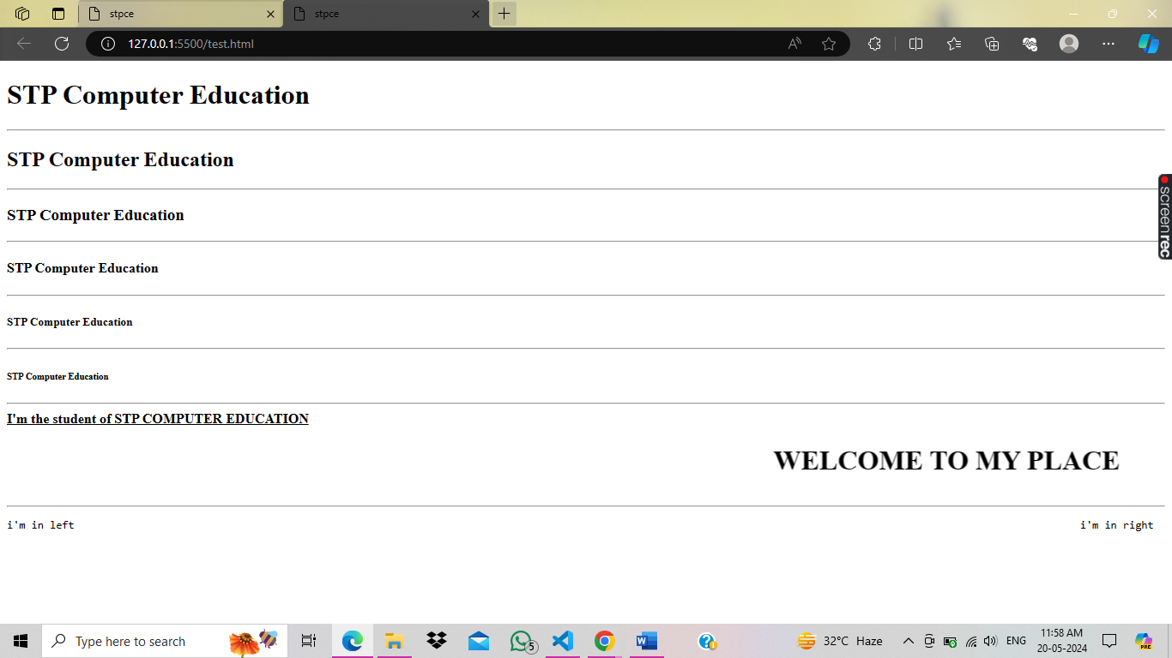

**Chapter - 6**

**HTML Formatting Tags**

**Empty Element Tags**

<hr> = horizontal line Tag

<br> = Line Break Tag

**Pre Formatting tag**

<pre> = This tag is accept keyboard formatting

**Formatting Tags**

<b> : Define bold text

<u> : Define underline text

<i> : Define italic text

<em> : Define emphasized text

<sup> : Define superscript text

<sub> : Define subscript text

<strong> : Define strong text

<small> : Define small text

<mark> : Define highlighted text

<!DOCTYPE html>

<html>

  <head>

    <title>Formatting Tags</title>

  </head>

  <body>

    <center>

      <h1>Formatting Tags</h1>

    </center>

    <hr />

    <b>STP computer education is a programming institute</b>

    <br /><br />

    <i>STP computer education is a programming institute</i>

    <br /><br />

    <u>STP computer education is a programming institute</u>

    <br /><br />

    <em>STP computer education is a programming institute</em>

    <br /><br />

    a<sup>2</sup> + b<sup>2</sup> <br /><br />

    H<sub>2</sub>O

    <br /><br />

    <strong>STP computer education is a programming institute</strong>

    <br /><br />

    STP COMPUTER <small>EDUCATION IS A PROGRAMMING</small> INSTITUTE

    <br /><br />

    STP computer education is a <mark>programming institute </mark>

  </body>

</html>

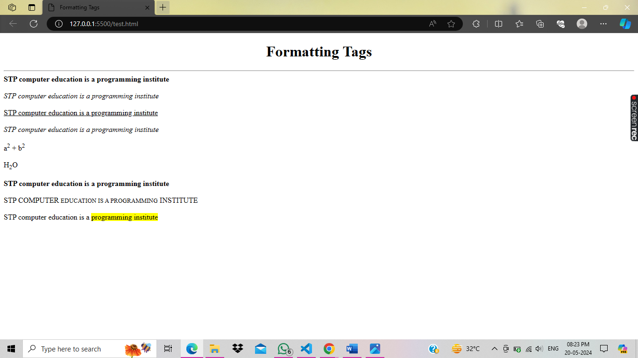

**Chapter -7**

**HTML Attributes**

**HTML**

HTML stands for hypertext markup language

HTML Attributes is the way to optimize the features of tags.

* Attributes are always used in opening tags.

Example:-

<tag attributename = “value”>

</tag>

* All HTML element have attributes.

|  |  |  |
| --- | --- | --- |
| **TAG NAME** | **ATTRIBUTES** | **VALUE** |
| **<body>** | bgcolor | “blue” |
| background | “image.jpg” |
| text | “blue” |
| link | “green” |
|
| **<h1> to <h6>** | align | “left” “right” “center” |
| title | “any text” |
|
| **<hr> (Empty element tag)** | color | “red” |
| width | “50%” “100” |
| size | “10” |
| align | “left” “right” “center” |
|
| **<marquee>** | direction | “up” “down” “right” “left” |
| behavior | “scroll” “alternate” |
| scrollamount | “50%” “20” |
| bgcolor | “blue” |

<!DOCTYPE html>

<html>

  <head>

    <title>Home</title>

  </head>

  <body bgcolor="#D1FF33" background="image.jpg" text="white">

    <h1 align="center" title="Welcome to my screen">

      Welcome to STP Computer Education

    </h1>

    <hr color="yellow" width="50%" size="5" align="center">

    <marquee direction="right" scrollamount="15" behavior="alternate" bgcolor="#D1FF33" text="black">

      <h2 text="black">Welcome to My Screen</h2>

    </marquee>

  </body>

</html>

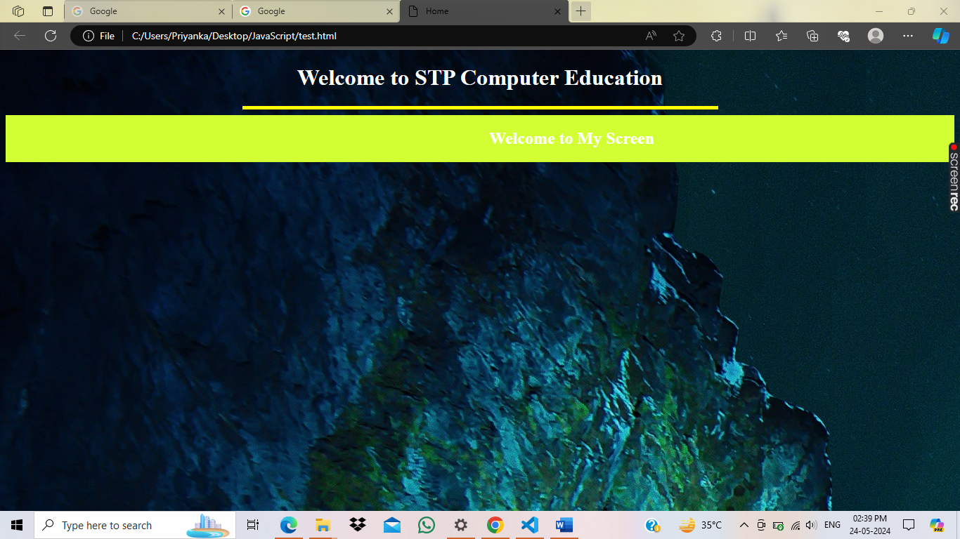

**Chapter -8**

**HTML Graphics Coding & Editing With Photoshop**

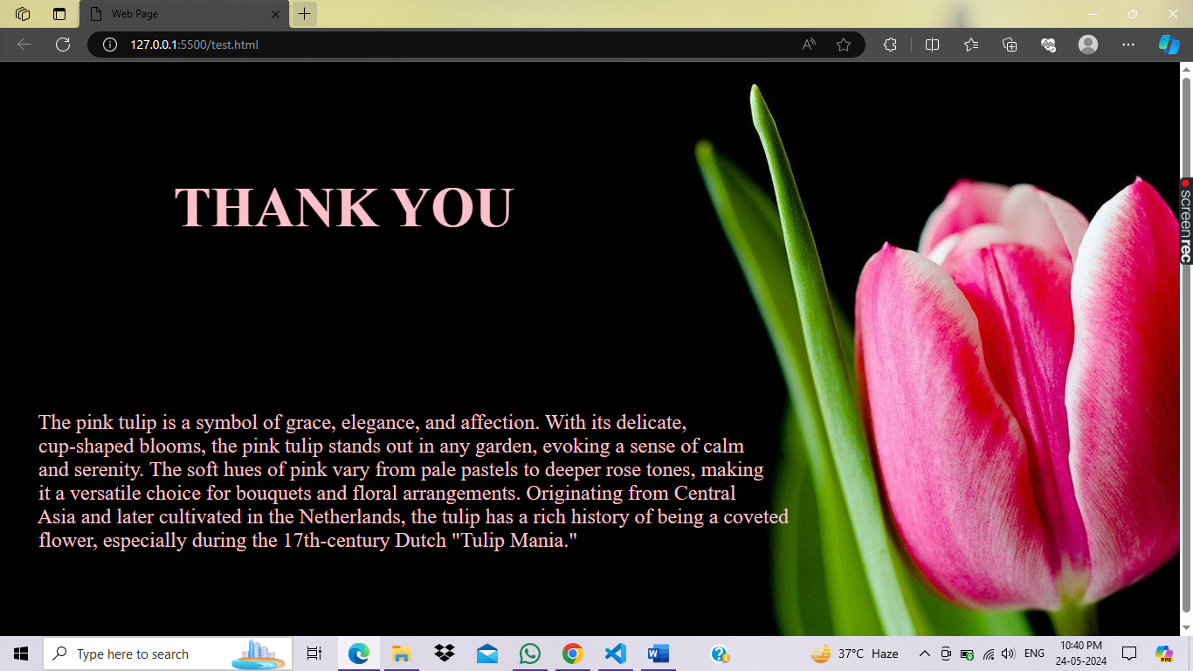

<!DOCTYPE html>

<html>

  <head>

    <title>Web Page</title>

  </head>

  <!-- <body background="file.jpg"> -->

  <body background="file2.jpg" text="white">

    <pre>

        <font size="6" color="pink" face="Times New Roman">

            <h1>            THANK YOU</h1>

        </font>

        <font size="5" color="pink" face="Times New Roman" >

              <p>      The pink tulip is a symbol of grace, elegance, and affection. With its delicate,

      cup-shaped blooms, the pink tulip stands out in any garden, evoking a sense of calm

      and serenity. The soft hues of pink vary from pale pastels to deeper rose tones, making

      it a versatile choice for bouquets and floral arrangements. Originating from Central

      Asia and later cultivated in the Netherlands, the tulip has a rich history of being a coveted

      flower, especially during the 17th-century Dutch "Tulip Mania." </p>

    </font>

    </pre>

  </body>

</html>

**Chapter -9**

**HTML Live Project Part 1**

**Songs**

**About**

**Movies**

**Images**

**Home**

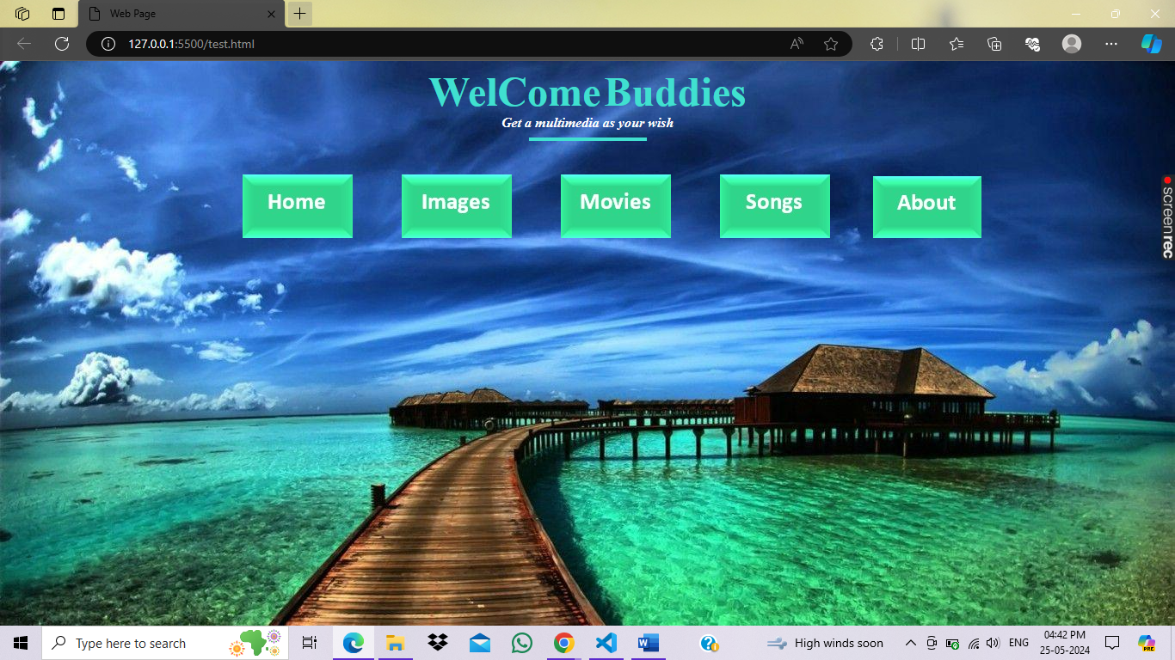

<!DOCTYPE html>

<html>

  <head>

    <title>Web Page</title>

  </head>

  <!-- <body background="file.jpg"> -->

  <body background="images/wallpaper.jpg" text="white">

    <center>

      <font size="7" face="Modern No. 20" color="Turquoise"

        ><b>WelCome</b></font

      >

      <font size="7" face="Modern No. 20" color="Turquoise"><b>Buddies</b></font

      ><br />

      <font face="Modern No. 20">

        <b><i>Get a multimedia as your wish</i></b>

      </font>

      <hr width="10%" color="Turquoise" size="4" />

      <br>

      <pre>

        <img src="images/menu/Home.jpg" />        <img src="images/menu/Images.jpg" />        <img src="images/menu/Movies.jpg" />        <img src="images/menu/Songs.jpg" />       <img src="images/menu/About.jpg" />

      </pre>

    </center>

  </body>

</html>

**HTML Live Project Part 2**

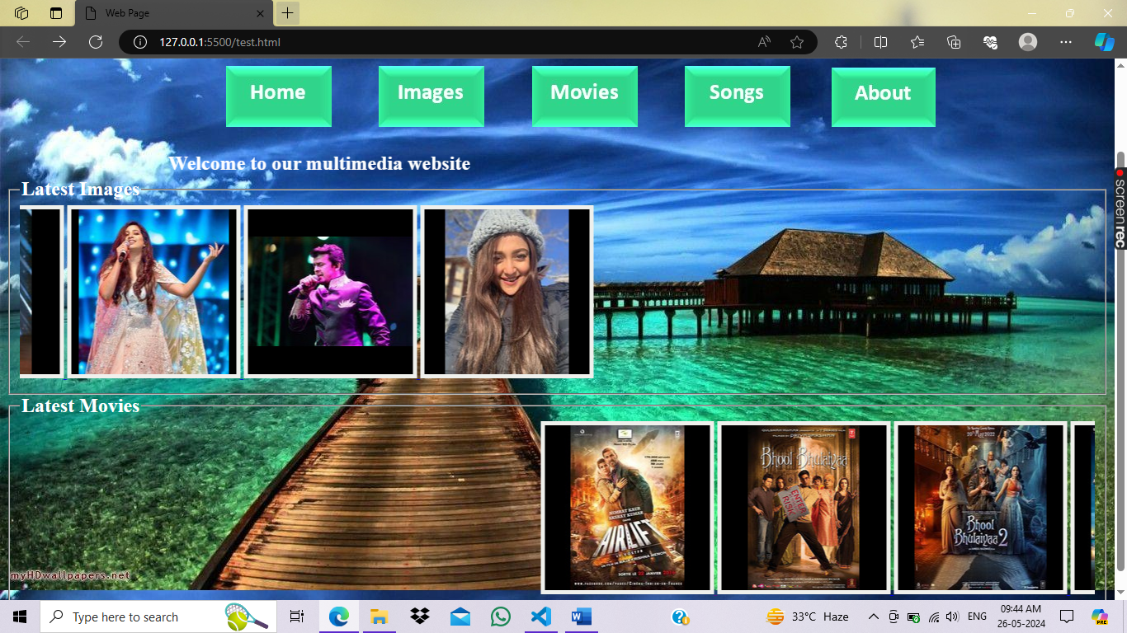

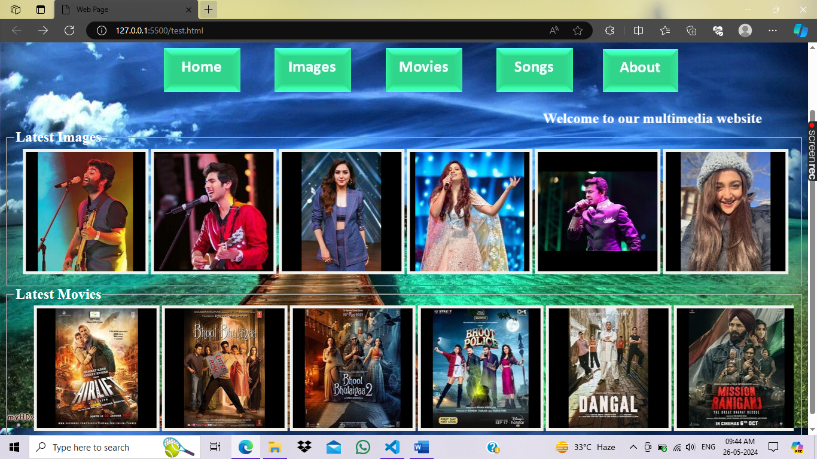

<!DOCTYPE html>

<html>

  <head>

    <title>Web Page</title>

  </head>

  <!-- <body background="file.jpg"> -->

  <body background="images/wallpaper.jpg" text="white">

    <center>

      <font size="7" face="Modern No. 20" color="#eff0ec"><b>MEDIA</b></font>

      <!-- <font size="7" face="Modern No. 20" color="Turquoise"><b>Buddies</b></font> -->

      <br />

      <font face="Modern No. 20">

        <b><i>Get a multimedia as your wish</i></b>

      </font>

      <hr width="10%" color="#eff0ec" size="4" />

      <br />

      <pre>

        <img src="images/menu/Home.jpg" />        <img src="images/menu/Images.jpg" />        <img src="images/menu/Movies.jpg" />        <img src="images/menu/Songs.jpg" />       <img src="images/menu/About.jpg" />

      </pre>

    </center>

    <marquee scrollamount="10">

      <font size="5" face="Modern No. 20">

        <b>Welcome to our multimedia website</b>

      </font>

    </marquee>

    <fieldset>

      <legend>

        <font size="5" face="Modern No. 20">

          <b>Latest Images</b>

        </font>

      </legend>

      <marquee direction="right">

        <center>

          <a href="images/menu/Arijit_Singh.jpg" download="download">

            <img

              src="images/Arijit_Singh.jpg"

              style="border: 5px solid #eff0ec"

              alt="Arijit Singh"

            />

          </a>

          <a href="images/menu/Armaan_Malik.jpg" download="download">

            <img

              src="images/Armaan_Malik.jpg"

              style="border: 5px solid #eff0ec"

              alt="Armaan Malik"

            />

          </a>

          <a href="images/menu/Neeti_Mohan.jpg" download="download">

            <img

              src="images/Neeti_Mohan.jpg"

              style="border: 5px solid #eff0ec"

              alt="Neeti Mohan"

            />

          </a>

          <a href="images/menu/Shreya-Ghoshal.jpg" download="download">

            <img

              src="images/Shreya-Ghoshal.jpg"

              style="border: 5px solid #eff0ec"

              alt="Shreya Ghoshal"

            />

          </a>

          <a href="images/menu/Sonu_Nigam.jpg" download="download">

            <img

              src="images/Sonu_Nigam.jpg"

              style="border: 5px solid #eff0ec"

              alt="Sonu Nigam"

            />

          </a>

          <a href="images/menu/Monali.jpg" download="download">

            <img

              src="images/Monali.jpg"

              style="border: 5px solid #eff0ec"

              alt="Monali Thakur"

            />

          </a>

        </center>

      </marquee>

    </fieldset>

    <fieldset>

      <legend>

        <font size="5"><b>Latest Movies</b></font>

      </legend>

      <marquee>

        <center>

          <a href="images/menu/Airlift.jpg">

            <img src="images/Airlift.jpg" style="border: 5px solid #eff0ec" />

          </a>

          <a href="images/menu/BhoolBhulaiya.jpg">

            <img

              src="images/BhoolBhulaiya.jpg"

              style="border: 5px solid #eff0ec"

            />

          </a>

          <a href="images/menu/BhoolBhulaiya2.jpg">

            <img

              src="images/BhoolBhulaiya2.jpg"

              style="border: 5px solid #eff0ec"

            />

          </a>

          <a href="images/menu/BhootPolice.jpg">

            <img

              src="images/BhootPolice.jpg"

              style="border: 5px solid #eff0ec"

            />

          </a>

          <a href="images/menu/Dangal.jpg">

            <img src="images/Dangal.jpg" style="border: 5px solid #eff0ec" />

          </a>

          <a href="images/menu/Mission-Raniganj.jpg">

            <img

              src="images/Mission-Raniganj.jpg"

              style="border: 5px solid #eff0ec"

            />

          </a>

        </center>

      </marquee>

    </fieldset>

  </body>

</html>

**HTML Live Project Part 3**

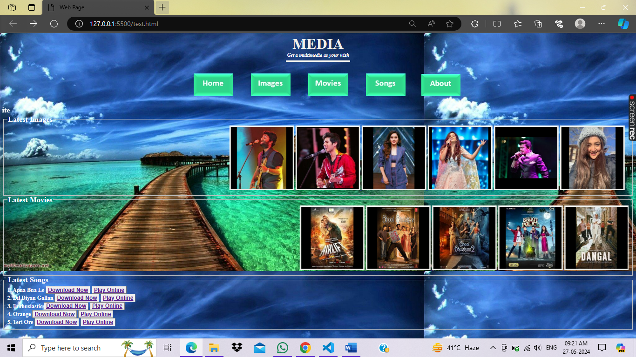

<!DOCTYPE html>

<html>

  <head>

    <title>Web Page</title>

  </head>

  <!-- <body background="file.jpg"> -->

  <body background="images/wallpaper.jpg" text="white">

    <center>

      <font size="7" face="Modern No. 20" color="#eff0ec"><b>MEDIA</b></font>

      <!-- <font size="7" face="Modern No. 20" color="Turquoise"><b>Buddies</b></font> -->

      <br />

      <font face="Modern No. 20">

        <b><i>Get a multimedia as your wish</i></b>

      </font>

      <hr width="10%" color="#eff0ec" size="4" />

      <br />

      <pre>

        <img src="images/menu/Home.jpg" />        <img src="images/menu/Images.jpg" />        <img src="images/menu/Movies.jpg" />        <img src="images/menu/Songs.jpg" />       <img src="images/menu/About.jpg" />

      </pre>

    </center>

    <marquee scrollamount="10">

      <font size="5" face="Modern No. 20">

        <b>Welcome to our multimedia website</b>

      </font>

    </marquee>

    <fieldset>

      <legend>

        <font size="5" face="Modern No. 20">

          <b>Latest Images</b>

        </font>

      </legend>

      <marquee direction="right">

        <center>

          <a href="images/menu/Arijit_Singh.jpg" download="download">

            <img

              src="images/Arijit_Singh.jpg"

              style="border: 5px solid #eff0ec"

              alt="Arijit Singh"

            />

          </a>

          <a href="images/menu/Armaan_Malik.jpg" download="download">

            <img

              src="images/Armaan_Malik.jpg"

              style="border: 5px solid #eff0ec"

              alt="Armaan Malik"

            />

          </a>

          <a href="images/menu/Neeti_Mohan.jpg" download="download">

            <img

              src="images/Neeti_Mohan.jpg"

              style="border: 5px solid #eff0ec"

              alt="Neeti Mohan"

            />

          </a>

          <a href="images/menu/Shreya-Ghoshal.jpg" download="download">

            <img

              src="images/Shreya-Ghoshal.jpg"

              style="border: 5px solid #eff0ec"

              alt="Shreya Ghoshal"

            />

          </a>

          <a href="images/menu/Sonu_Nigam.jpg" download="download">

            <img

              src="images/Sonu_Nigam.jpg"

              style="border: 5px solid #eff0ec"

              alt="Sonu Nigam"

            />

          </a>

          <a href="images/menu/Monali.jpg" download="download">

            <img

              src="images/Monali.jpg"

              style="border: 5px solid #eff0ec"

              alt="Monali Thakur"

            />

          </a>

        </center>

      </marquee>

    </fieldset>

    <fieldset>

      <legend>

        <font size="5"><b>Latest Movies</b></font>

      </legend>

      <marquee direction="left">

        <center>

          <a href="images/menu/Airlift.jpg">

            <img src="images/Airlift.jpg" style="border: 5px solid #eff0ec" />

          </a>

          <a href="images/menu/BhoolBhulaiya.jpg">

            <img

              src="images/BhoolBhulaiya.jpg"

              style="border: 5px solid #eff0ec"

            />

          </a>

          <a href="images/menu/BhoolBhulaiya2.jpg">

            <img

              src="images/BhoolBhulaiya2.jpg"

              style="border: 5px solid #eff0ec"

            />

          </a>

          <a href="images/menu/BhootPolice.jpg">

            <img

              src="images/BhootPolice.jpg"

              style="border: 5px solid #eff0ec"

            />

          </a>

          <a href="images/menu/Dangal.jpg">

            <img src="images/Dangal.jpg" style="border: 5px solid #eff0ec" />

          </a>

          <a href="images/menu/Mission-Raniganj.jpg">

            <img

              src="images/Mission-Raniganj.jpg"

              style="border: 5px solid #eff0ec"

            />

          </a>

        </center>

      </marquee>

    </fieldset>

    <fieldset>

      <legend>

        <font size="5">

          <b>Latest Songs</b>

        </font>

      </legend>

      <font size="4"><b>1. Apna Bna Le </b></font>

      <button>

        <a href="images/music/ApnaBnaLe.mp3" download="download" title="Apna Bna Le">

          <font size="4" ><b>Download Now</b></font>

        </a>

      </button>

      <button>

        <a href="images/music/ApnaBnaLe.mp3">

          <font size="4"><b>Play Online </b></font>

        </a>

      </button>

      <br>

      <font size="4"><b>2. Dil Diyan Gallan </b></font>

      <button>

        <a href="images/music/DilDiyanGallan.mp3" download="download" title="Dil Diyan Gallan">

          <font size="4" ><b>Download Now</b></font>

        </a>

      </button>

      <button>

        <a href="images/music/DilDiyanGallan.mp3">

          <font size="4"><b>Play Online </b></font>

        </a>

      </button>

      <br>

      <font size="4"><b>3. Enthusiastic </b></font>

      <button>

        <a href="images/music/Enthusiastic.mp3" download="download" title="Enthusiastic">

          <font size="4" ><b>Download Now</b></font>

        </a>

      </button>

      <button>

        <a href="images/music/Enthusiastic.mp3">

          <font size="4"><b>Play Online </b></font>

        </a>

      </button>

      <br>

      <font size="4"><b>4. Orange </b></font>

      <button>

        <a href="images/music/Orange.mp3" download="download" title="Orange">

          <font size="4" ><b>Download Now</b></font>

        </a>

      </button>

      <button>

        <a href="images/music/Orange.mp3">

          <font size="4"><b>Play Online </b></font>

        </a>

      </button>

      <br>

      <font size="4"><b>5. Teri Ore </b></font>

      <button>

        <a href="images/music/TeriOre.mp3" download="download" title="Teri Ore">

          <font size="4" ><b>Download Now</b></font>

        </a>

      </button>

      <button>

        <a href="images/music/TeriOre.mp3">

          <font size="4"><b>Play Online </b></font>

        </a>

      </button>

    </fieldset>

  </body>

</html>

**Chapter -10**

**HTML Sub Page Creation**

Test.html

<!DOCTYPE html>

<html>

  <head>

    <title>Web Page</title>

  </head>

  <!-- <body background="file.jpg"> -->

  <body background="images/wallpaper.jpg" text="white">

    <center>

      <font size="7" face="Modern No. 20" color="#eff0ec"><b>MEDIA</b></font>

      <!-- <font size="7" face="Modern No. 20" color="Turquoise"><b>Buddies</b></font> -->

      <br />

      <font face="Modern No. 20">

        <b><i>Get a multimedia as your wish</i></b>

      </font>

      <hr width="10%" color="#eff0ec" size="4" />

      <br />

      <img src="images/menu/Home.jpg" /> &nbsp;&nbsp;&nbsp;&nbsp;&nbsp;

      <a href="images.html"><img src="images/menu/Images.jpg" /></a>

      &nbsp;&nbsp;&nbsp;&nbsp;&nbsp;

      <a href="movies.html"><img src="images/menu/Movies.jpg" /></a>

      &nbsp;&nbsp;&nbsp;&nbsp;&nbsp;

      <a href="songs.html"><img src="images/menu/Songs.jpg" /></a>

      &nbsp;&nbsp;&nbsp;&nbsp;&nbsp;

      <a href="about.html"><img src="images/menu/About.jpg" /></a>

      &nbsp;&nbsp;&nbsp;&nbsp;&nbsp;

    </center>

    <marquee scrollamount="10">

      <font size="5" face="Modern No. 20">

        <b>Welcome to our multimedia website</b>

      </font>

    </marquee>

    <fieldset>

      <legend>

        <font size="5" face="Modern No. 20">

          <b>Latest Images</b>

        </font>

      </legend>

      <marquee direction="right">

        <center>

          <a href="images/menu/Arijit_Singh.jpg" download="download">

            <img

              src="images/Arijit_Singh.jpg"

              style="border: 5px solid #eff0ec"

              alt="Arijit Singh"

            />

          </a>

          <a href="images/menu/Armaan_Malik.jpg" download="download">

            <img

              src="images/Armaan_Malik.jpg"

              style="border: 5px solid #eff0ec"

              alt="Armaan Malik"

            />

          </a>

          <a href="images/menu/Neeti_Mohan.jpg" download="download">

            <img

              src="images/Neeti_Mohan.jpg"

              style="border: 5px solid #eff0ec"

              alt="Neeti Mohan"

            />

          </a>

          <a href="images/menu/Shreya-Ghoshal.jpg" download="download">

            <img

              src="images/Shreya-Ghoshal.jpg"

              style="border: 5px solid #eff0ec"

              alt="Shreya Ghoshal"

            />

          </a>

          <a href="images/menu/Sonu_Nigam.jpg" download="download">

            <img

              src="images/Sonu_Nigam.jpg"

              style="border: 5px solid #eff0ec"

              alt="Sonu Nigam"

            />

          </a>

          <a href="images/menu/Monali.jpg" download="download">

            <img

              src="images/Monali.jpg"

              style="border: 5px solid #eff0ec"

              alt="Monali Thakur"

            />

          </a>

        </center>

      </marquee>

    </fieldset>

    <fieldset>

      <legend>

        <font size="5"><b>Latest Movies</b></font>

      </legend>

      <marquee direction="left">

        <center>

          <a href="images/menu/Airlift.jpg">

            <img src="images/Airlift.jpg" style="border: 5px solid #eff0ec" />

          </a>

          <a href="images/menu/BhoolBhulaiya.jpg">

            <img

              src="images/BhoolBhulaiya.jpg"

              style="border: 5px solid #eff0ec"

            />

          </a>

          <a href="images/menu/BhoolBhulaiya2.jpg">

            <img

              src="images/BhoolBhulaiya2.jpg"

              style="border: 5px solid #eff0ec"

            />

          </a>

          <a href="images/menu/BhootPolice.jpg">

            <img

              src="images/BhootPolice.jpg"

              style="border: 5px solid #eff0ec"

            />

          </a>

          <a href="images/menu/Dangal.jpg">

            <img src="images/Dangal.jpg" style="border: 5px solid #eff0ec" />

          </a>

          <a href="images/menu/Mission-Raniganj.jpg">

            <img

              src="images/Mission-Raniganj.jpg"

              style="border: 5px solid #eff0ec"

            />

          </a>

        </center>

      </marquee>

    </fieldset>

    <fieldset>

      <legend>

        <font size="5">

          <b>Latest Songs</b>

        </font>

      </legend>

      <font size="4"><b>1. Apna Bna Le </b></font>

      &nbsp;&nbsp;&nbsp;&nbsp;&nbsp;&nbsp;&nbsp;&nbsp;&nbsp;&nbsp;&nbsp;&nbsp;&nbsp;&nbsp;&nbsp;

      <button>

        <a

          href="images/music/ApnaBnaLe.mp3"

          download="download"

          title="Apna Bna Le"

        >

          <font size="4"><b>Download Now</b></font>

        </a>

      </button>

      &nbsp;&nbsp;&nbsp;&nbsp;&nbsp;&nbsp;&nbsp;&nbsp;&nbsp;&nbsp;&nbsp;&nbsp;&nbsp;&nbsp;&nbsp;

      <button>

        <a href="images/music/ApnaBnaLe.mp3">

          <font size="4"><b>Play Online </b></font>

        </a>

      </button>

      <br />

      <font size="4"><b>2. Dil Diyan Gallan </b></font>

      &nbsp;&nbsp;&nbsp;&nbsp;&nbsp;&nbsp;&nbsp;&nbsp;

      <button>

        <a

          href="images/music/DilDiyanGallan.mp3"

          download="download"

          title="Dil Diyan Gallan"

        >

          <font size="4"><b>Download Now</b></font>

        </a>

      </button>

      &nbsp;&nbsp;&nbsp;&nbsp;&nbsp;&nbsp;&nbsp;&nbsp;&nbsp;&nbsp;&nbsp;&nbsp;&nbsp;&nbsp;&nbsp;

      <button>

        <a href="images/music/DilDiyanGallan.mp3">

          <font size="4"><b>Play Online </b></font>

        </a>

      </button>

      <br />

      <font size="4"><b>3. Enthusiastic</b></font>

      &nbsp;&nbsp;&nbsp;&nbsp;&nbsp;&nbsp;&nbsp;&nbsp;&nbsp;&nbsp;&nbsp;&nbsp;&nbsp;&nbsp;&nbsp;&nbsp;&nbsp;

      <button>

        <a

          href="images/music/Enthusiastic.mp3"

          download="download"

          title="Enthusiastic"

        >

          <font size="4"><b>Download Now</b></font>

        </a>

      </button>

      &nbsp;&nbsp;&nbsp;&nbsp;&nbsp;&nbsp;&nbsp;&nbsp;&nbsp;&nbsp;&nbsp;&nbsp;&nbsp;&nbsp;&nbsp;

      <button>

        <a href="images/music/Enthusiastic.mp3">

          <font size="4"><b>Play Online </b></font>

        </a>

      </button>

      <br />

      <font size="4"><b>4. Orange </b></font>

      &nbsp;&nbsp;&nbsp;&nbsp;&nbsp;&nbsp;&nbsp;&nbsp;&nbsp;&nbsp;&nbsp;&nbsp;&nbsp;&nbsp;&nbsp;&nbsp;&nbsp;&nbsp;&nbsp;&nbsp;&nbsp;&nbsp;&nbsp;&nbsp;&nbsp;&nbsp;

      <button>

        <a href="images/music/Orange.mp3" download="download" title="Orange">

          <font size="4"><b>Download Now</b></font>

        </a>

      </button>

      &nbsp;&nbsp;&nbsp;&nbsp;&nbsp;&nbsp;&nbsp;&nbsp;&nbsp;&nbsp;&nbsp;&nbsp;&nbsp;&nbsp;&nbsp;

      <button>

        <a href="images/music/Orange.mp3">

          <font size="4"><b>Play Online </b></font>

        </a>

      </button>

      <br />

      <font size="4"><b>5. Teri Ore </b></font>

      &nbsp;&nbsp;&nbsp;&nbsp;&nbsp;&nbsp;&nbsp;&nbsp;&nbsp;&nbsp;&nbsp;&nbsp;&nbsp;&nbsp;&nbsp;&nbsp;&nbsp;&nbsp;&nbsp;&nbsp;&nbsp;&nbsp;&nbsp;&nbsp;

      <button>

        <a href="images/music/TeriOre.mp3" download="download" title="Teri Ore">

          <font size="4"><b>Download Now</b></font>

        </a>

      </button>

      &nbsp;&nbsp;&nbsp;&nbsp;&nbsp;&nbsp;&nbsp;&nbsp;&nbsp;&nbsp;&nbsp;&nbsp;&nbsp;&nbsp;&nbsp;

      <button>

        <a href="images/music/TeriOre.mp3">

          <font size="4"><b>Play Online </b></font>

        </a>

      </button>

    </fieldset>

  </body>

</html>

Images.html, movies.html, songs.html and about.html

<!DOCTYPE html>

<html>

    <head>

        <title>About Page</title>

    </head>

    <body background="images/wallpaper.jpg" text="white">

    <center>

      <font size="7" face="Modern No. 20" color="#eff0ec"><b>MEDIA</b></font>

      <!-- <font size="7" face="Modern No. 20" color="Turquoise"><b>Buddies</b></font> -->

      <br />

      <font face="Modern No. 20">

        <b><i>Get a multimedia as your wish</i></b>

      </font>

      <hr width="10%" color="#eff0ec" size="4" />

      <br />

    </center>

    </body>

</html>

**Chapter – 12**

**HTML Web App Task**

<!DOCTYPE html>

<html>

  <head>

    <title>No. of Images</title>

    <style>

      #imageContainer {

        text-align: center;

      }

      button {

        font-size: 180%;

        margin: 10px;

        border-radius: 6px;

        background-color: rgb(189, 239, 248);

        color: rgb(187, 66, 116);

      }

      #buttonContainer {

        text-align: center;

      }

    </style>

  </head>

  <body>

    <div id="imageContainer">

      <img id="currentImage" src="images/Arijit_Singh.jpg" />

    </div>

    <div id="buttonContainer">

      <button onclick="previousButton()">Back</button>

      <button onclick="nextButton()">Next</button>

    </div>

    <script>

      const images = [

        "images/Arijit_Singh.jpg",

        "images/Armaan_Malik.jpg",

        "images/Monali.jpg",

        "images/Neeti_Mohan.jpg",

        "images/Shreya-Ghoshal.jpg",

        "images/Sonu_Nigam.jpg",

      ];

      let currentIndex = 0;

      function update() {

        document.getElementById("currentImage").src = images[currentIndex];

      }

      function nextButton() {

        currentIndex = (currentIndex + 1) % images.length;

     // currentIndex = ( 0 + 1 ) % 6 = 1

     // currentIndex = ( 1 + 1 ) % 6 = 2

     // currentIndex = ( 2 + 1 ) % 6 = 3

     // currentIndex = ( 3 + 1 ) % 6 = 4

     // currentIndex = ( 4 + 1 ) % 6 = 5

     // currentIndex = ( 5 + 1 ) % 6 = 6

        update()

      }

      function previousButton() {

        currentIndex = (currentIndex - 1 + images.length) % images.length;

     // currentIndex = ( 6 - 1 + 6 ) % 6 = ( 12 - 1 ) % 6 = 11 % 6 = 5

     // currentIndex = ( 5 - 1 + 6 ) % 6 = ( 11 - 1 ) % 6 = 10 % 6 = 4

     // currentIndex = ( 4 - 1 + 6 ) % 6 = ( 10 - 1 ) % 6 = 9 % 6 = 3

     // currentIndex = ( 3 - 1 + 6 ) % 6 = ( 9 - 1 ) % 6 = 8 % 6 = 2

     // currentIndex = ( 2 - 1 + 6 ) % 6 = ( 8 - 1 ) % 6 = 7 % 6 = 1

     // currentIndex = ( 1 - 1 + 6 ) % 6 = ( 7 - 1 ) % 6 = 6 % 6 = 0

        update()

      }

    </script>

  </body>

</html>

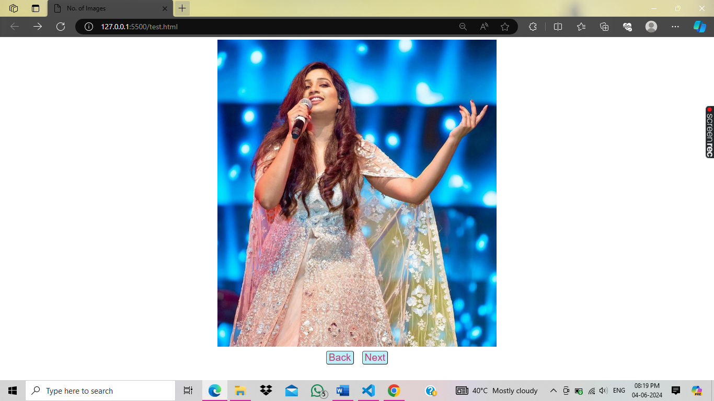

**Chapter – 15**

**HTML Advanced Multimedia with Plug-ins**

* **Audio =** <audio></audio>
* **Video =** <video></video>
* **Image =** <img>
* **Plug-ins =** <embed>, <object> (pdf)

**Attributes of <audio> tag**

|  |  |
| --- | --- |
| **Attribute Name** | **Value** |
| src | “audioname.mp3” |
| controls | controls |
| autoplay | autoplay |
| muted | muted |

<!DOCTYPE html>

<html>

  <head>

    <title>Multimedia.com</title>

  </head>

  <body>

    <font size = 5>

      <h1 align="center">Multimedia.com</h1>

    </font>

    <hr>

    <h3>1. Apna Bna Le</h3>

    <audio controls autoplay="true" src="images/music/ApnaBnaLe.mp3"></audio>

    <a href="images/music/ApnaBnaLe.mp3" download="download"> Download</a>

  </body>

</html>

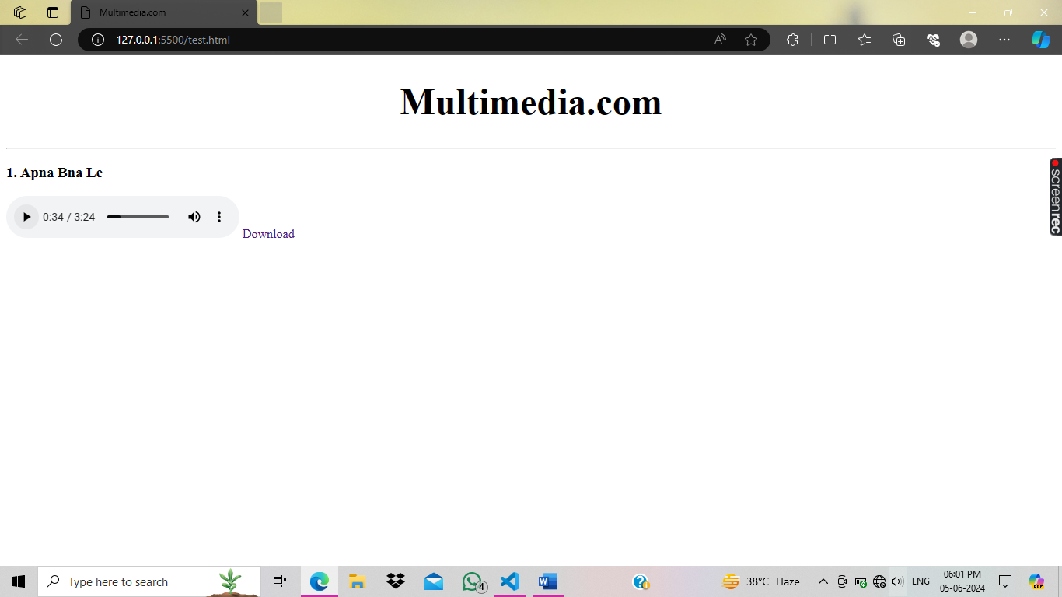

**Attributes of <video> tag**

|  |  |
| --- | --- |
| **Attribute Name** | **Value** |
| **src** | **“videoname.mp3”** |
| **controls** | **controls** |
| **autoplay** | **autoplay** |
| **muted** | **muted** |
| **width** | **“720”** |
| **height** | **“480”** |

<!DOCTYPE html>

<html>

  <head>

    <title>Multimedia.com</title>

  </head>

  <body>

    <font size = 5>

      <h1 align="center">Multimedia.com</h1>

    </font>

    <hr>

    <audio controls autoplay src="images/music/ApnaBnaLe.mp3"></audio>

    <br>

    <video controls autoplay src="images/videos/Bonfire.mp4" width="500px" height="500px"></video>

  </body>

</html>

**Attributes of <img> tag**

|  |  |
| --- | --- |
| **Attribute Name** | **Value** |
| **src** | **“imagename.jpg”** |
| **width** | **“720”** |
| **height** | **“480”** |
| **alt** | **“imagename”** |
| **border** | **1,2,3,4** |

Note :- Attribute of <embed> tag. Don’t close this </embed> tag like this. The <embed> tag defines a container for an external resource, such as web page, a picture, a media player, or a plug-in application.

<!DOCTYPE html>

<html>

  <head>

    <title>Multimedia.com</title>

  </head>

  <body>

    <font size = 5>

      <h1 align="center">Multimedia.com</h1>

    </font>

    <hr>

    <embed src="images/Priyanka.pdf" width="500px" height="500px">

  </body>

</html>

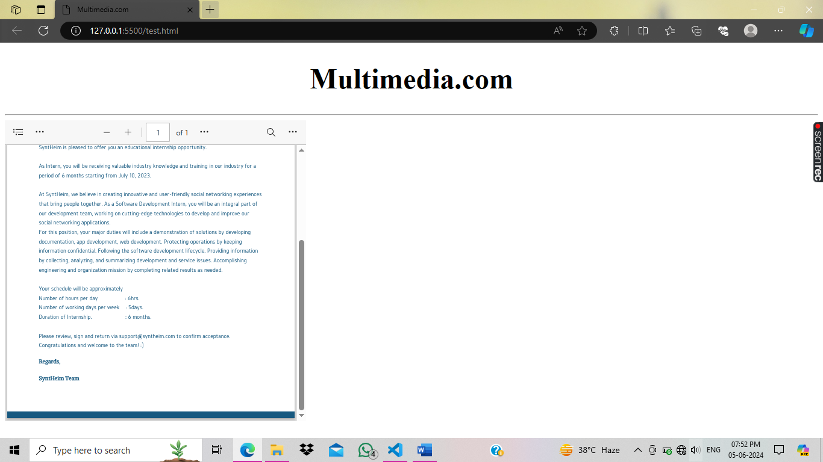

**Attributes of <embed> tag**

|  |  |
| --- | --- |
| **Attribute Name** | **Value** |
| **src** | **“filename.ext”** |
| **width** | **“720”** |
| **height** | **“480”** |

**Attributes of <object> tag**

|  |  |
| --- | --- |
| **Attribute Name** | **Value** |
| **data** | **“filename.ext”** |
| **width** | **“720”** |
| **height** | **“480”** |

Note:- Both the <embed> and <object> tags are used to load external plugin content, and they are quite similar in functionality. But the first thing we should note is that the <embed> tag is a deprecated HTML tag. So, the <object> tag is currently the standard tag used to embed something on a page.

<!DOCTYPE html>

<html>

  <head>

    <title>Multimedia.com</title>

  </head>

  <body>

    <font size = 5>

      <h1 align="center">Multimedia.com</h1>

    </font>

    <hr>

    <embed src="images/videos/Bonfire.mp4" width="500px" height="500px">

    <object data="images/videos/Bonfire.mp4" width="500px" height="500px"></object>

  </body>

</html>

**Chapter – 16**

**HTML List**

Lists are the way to display contents in bullets and numbering formation.

**Bullets : • ▪ ◦**

**Numbering: 1 2 3 , A B C , i ii iii , a b c d .**

**The Two Types of List**

**1.** Unordered List( unnumbered list) • ▪ ◦

**2.** Ordered List( numbered list) 1 2 3 , A B C , i ii iii , a b c d .

**Unordered List tag = <ul> </ul>**

<ul>

<li>this is a list</li>

<li>this is a list</li>

</ul>

**Attribute of Unordered list <ul> tag**

|  |  |
| --- | --- |
| **Attribute Name** | **Value** |
| type | “circle” , “square” , “disk” |

**Ordered List tag = <ol> </ol>**

<ol>

<li>this is a list</li>

<li>this is a list</li>

</ol>

|  |  |
| --- | --- |
| **Attribute Name** | **Value** |
| type | “a” , “A” , “i” |
| start | 8 |

**Chapter – 19 HTML Table**

Table is a block structure of rows and column which allows you to create a webpage layout in html language.

**ROWS :** bank line

**COLUMN :**  pillars

**List of some tags**

1. <table> </table> : start table coding.
2. <tr> </tr> : to create row.
3. <td> </td> : to create columns.
4. <th> </th> : to create heading for columns.
5. <caption> </caption> : to define table name.

**Attributes of <table> tag**

|  |  |
| --- | --- |
| **Attribute Name** | **Value** |
| width | 500 |
| height | 600 |
| border | 1 |
| bordercolor | “red” |
| align | “left” , “ center” , “ right” |
| bgcolor | “skyblue” |
| cellspacing | 20 |

<!DOCTYPE html>

<html>

  <head>

    <title>Multimedia.com</title>

  </head>

  <body align="center" text="white">

    <table

      width="200px"

      height="300px"

      border="1"

      align="left"

      bgcolor="purple"

      cellspacing="20"

      bordercolor="white"

    >

      <tr bgcolor="pink">

        <td><font size="7">a</font></td>

      </tr>

      <tr bgcolor="pink">

        <td><font size="7">b</font></td>

      </tr>

      <tr bgcolor="pink">

        <td><font size="7">c</font></td>

      </tr>

    </table>

  </body>

</html>

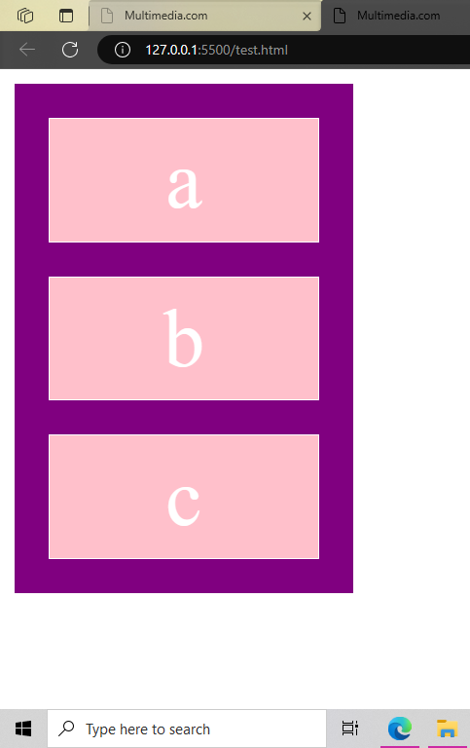

<!DOCTYPE html>

<html>

  <head>

    <title>Multimedia.com</title>

  </head>

  <body align="center" text="white">

    <table

      width="300px"

      height="100px"

      border="1"

      align="left"

      bgcolor="purple"

      cellspacing="10"

      bordercolor="white"

    >

      <tr bgcolor="pink">

        <td><font size="4">Home</font></td>

        <td><font size="4">Images</font></td>

        <td><font size="4">Songs</font></td>

        <td><font size="4">Movies</font></td>

        <td><font size="4">About</font></td>

      </tr>

    </table>

  </body>

****</html>

**Chapter – 20**

**HTML Table First Project Part 1**

<!DOCTYPE html>

<html>

  <head>

    <title>Project</title>

    <style>

      #image1 {

        border-radius: 50%;

      }

      #flowershop {

        border-radius: 2%;

      }

      button {

        color: rgb(11, 12, 14);

        background-color: rgb(199, 240, 241);

      }

    </style>

  </head>

  <body background="background.jpg">

    <table align="center" bordercolor="white" width="760px" height="570px">

      <!-- 1st Row -->

      <tr align="center">

        <td width="250px" height="208px" align="center">

          <img src="fb.png" width="42" height="40" />

          <img id="image1" src="linkdein.jpg" width="40" height="40" />

          <img id="image1" src="twitter.jpg" width="40" height="40" />

          <br /><br /><br /><br /><br /><br /><br /><br /><br />

        </td>

        <td width="260px" height="208px">

          <img width="120" height="130" src="logo.png" /><br />

          <img id="flowershop" width="170" height="20" src="domain.png" /><br />

          <img id="flowershop" width="100" height="20" src="tag.png" /><br />

        </td>

        <td width="250px" height="208px">

          <address>

            <font size="3" color="white">Patel Nagar, New Delhi<br /></font>

          </address>

          <address>

            <font size="3" color="white">Contact No. : 9999999999</font>

          </address>

          <br /><br /><br /><br /><br /><br /><br /><br /><br />

        </td>

      </tr>

      <!-- 2nd Row -->

      <tr bgcolor="#F0F0F0">

        <td height="50px" colspan="3">

          <table width="760px" height="50px" bordercolor="white" align="center">

            <tr>

              <td>

                <input placeholder="search flower name" />

                <button>Search</button>

              </td>

              <td></td>

              <td align="center">

                <font align="right" color="black">Home</font>

              </td>

              <td align="center">

                <font align="right" color="black">Shop Online</font>

              </td>

              <td align="center">

                <font align="right" color="black">Contact us</font>

              </td>

              <td align="center">

                <font align="right" color="black">About Us</font>

              </td>

            </tr>

          </table>

        </td>

      </tr>

      <!-- 3rd Row -->

      <tr>

        <td colspan="3" height="262px">

          <table

            width="760px"

            height="262px"

            bordercolor="white"

            bgcolor="white"

          >

            <tr>

              <td width="450px" background="images/Rose.jpg"></td>

              <!-- <td align="center"><font  color="white">Shop Online Flower</font></td> -->

              <td width="310px" align="center">

                <table

                  width="310px"

                  height="262px"

                  bordercolor="white"

                  cellspacing="10"

                >

                  <tr>

                    <font size="5" color="black">Shop Online Flower</font>

                  </tr>

                  <tr align="center">

                    <td>Your Name</td>

                    <td><input placeholder="Your Name" /></td>

                  </tr>

                  <tr align="center">

                    <td>Flower Name</td>

                    <td><input placeholder="Flower Name" /></td>

                  </tr>

                  <tr align="center">

                    <td>Quantity</td>

                    <td><input placeholder="Quantity" /></td>

                  </tr>

                  <tr align="center">

                    <td>Mobile No.</td>

                    <td><input placeholder="Mobile No." /></td>

                  </tr>

                  <tr align="center">

                    <td>Address</td>

                    <td>

                      <address><input placeholder="Address" /></address>

                    </td>

                  </tr>

                </table>

              </td>

            </tr>

          </table>

        </td>

      </tr>

      <!-- 4th Row -->

      <tr bgcolor="black">

        <td height="50px" colspan="3">

          <table width="760px" height="50px" bordercolor="white">

            <tr>

              <td>

                <address>

                  <font size="3" color="white">Patel Nagar, New Delhi</font>

                </address>

              </td>

              <td align="right">

                <address>

                  <font size="3" color="white"

                    >Developed By : STP Computer Education</font

                  >

                </address>

              </td>

            </tr>

          </table>

        </td>

      </tr>

    </table>

  </body>

</html>

**Chapter – 21**

**HTML Form**

Html Forms are the way to get any information from user on your web server.

First name

Last name

Mobile No.

**Submit**

**Tags**

**<form> </form>**

**<input> (Empty element tag)**

**<textarea> </textarea>**

Write your complaint here

Address

<!DOCTYPE html>

<html>

  <head>

    <title>Html Form</title>

  </head>

  <body>

    <form>

      First name <br />

      <input type="text" name="firstname"/><br /><br />

      Last name<br />

      <input type="text" name="lastname"/><br /><br />

      Mobile No.<br />

      <input type="number" name="mobile no" /><br /><br />

    </form>

  </body>

</html>

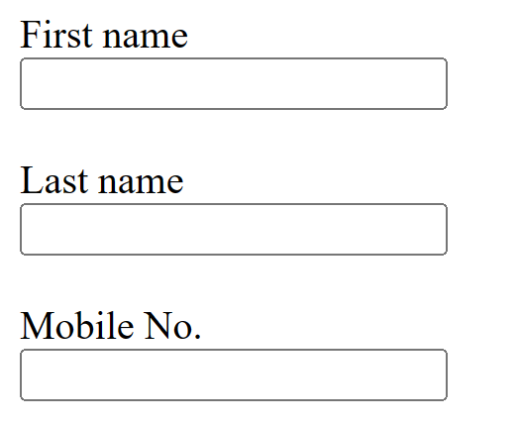

<!DOCTYPE html>

<html>

  <head>

    <title>Admission Form</title>

  </head>

  <body>

    <form>

      Student Name :

      <input name="student name" type="text" /><br /><br />

      Father's Name :

      <input type="text" name="father's name" /><br /><br />

      Mother's Name :

      <input type="text" name="mother's name" /><br /><br />

      Course Name :

      <input name="course name" type="text"><br /><br />

      Mobile No :

      <input name="Mobile No" type="number"><br /><br />

      Date Of Birth :

      <input name="DOB" type="date"> <br /><br />

      Email id :

      <input name="email id" type="email"> <br /><br />

      Address :

      <textarea name="address" ></textarea>

      <br><br>

      <input type="submit" value="Get Admission">

    </form>

  </body>

</html>

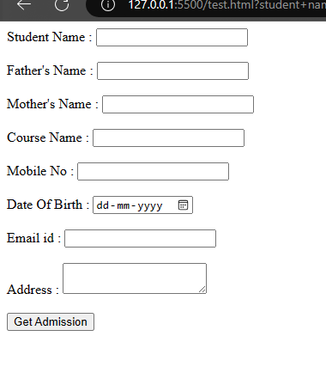

<!DOCTYPE html>

<html>

  <head>

    <title>Project</title>

    <style>

      #image1 {

        border-radius: 50%;

      }

      #flowershop {

        border-radius: 2%;

      }

      button {

        color: rgb(11, 12, 14);

        background-color: rgb(199, 240, 241);

      }

    </style>

  </head>

  <body background="background.jpg">

    <table align="center" bordercolor="white" width="760px" height="570px">

      <!-- 1st Row -->

      <tr align="center">

        <td width="250px" height="208px" align="center">

          <img src="fb.png" width="42" height="40" />

          <img id="image1" src="linkdein.jpg" width="40" height="40" />

          <img id="image1" src="twitter.jpg" width="40" height="40" />

          <br /><br /><br /><br /><br /><br /><br /><br /><br />

        </td>

        <td width="260px" height="208px">

          <img width="120" height="130" src="logo.png" /><br />

          <img id="flowershop" width="170" height="20" src="domain.png" /><br />

          <img id="flowershop" width="100" height="20" src="tag.png" /><br />

        </td>

        <td width="250px" height="208px">

          <address>

            <font size="3" color="white">Patel Nagar, New Delhi<br /></font>

          </address>

          <address>

            <font size="3" color="white">Contact No. : 9999999999</font>

          </address>

          <br /><br /><br /><br /><br /><br /><br /><br /><br />

        </td>

      </tr>

      <!-- 2nd Row -->

      <tr bgcolor="#F0F0F0">

        <td height="50px" colspan="3">

          <table width="760px" height="50px" bordercolor="white" align="center">

            <tr>

              <td>

                <form>

                  <input

                    type="search"

                    placeholder="search flower name"

                    size="25"

                    name="search"

                  />

                  <input type="submit" value="Search" />

                </form>

              </td>

              <td></td>

              <td align="center">

                <font align="right" color="black">Home</font>

              </td>

              <td align="center">

                <font align="right" color="black">Shop Online</font>

              </td>

              <td align="center">

                <font align="right" color="black">Contact us</font>

              </td>

              <td align="center">

                <font align="right" color="black">About Us</font>

              </td>

            </tr>

          </table>

        </td>

      </tr>

      <!-- 3rd Row -->

      <tr>

        <td colspan="3" height="262px">

          <table

            width="760px"

            height="262px"

            bordercolor="white"

            bgcolor="white"

          >

            <tr>

              <td

                width="450px"

                height="262px"

                background="images/Rose.jpg"

              ></td>

              <!-- <td align="center"><font  color="white">Shop Online Flower</font></td> -->

              <td width="310px" align="center" bgcolor="black">

                <form>

                  <table width="310px" height="262px">

                    <tr height="37px" align="center">

                      <td colspan="2">

                        <font size="5" color="white">Shop Online Flower</font>

                      </td>

                    </tr>

                    <tr height="37px" align="center">

                      <td><font color="white">Your Name</font></td>

                      <td>

                        <input

                          type="text"

                          name="Your Name"

                          placeholder="Your Name"

                        />

                      </td>

                    </tr>

                    <tr height="37px" align="center">

                      <td><font color="white">Flower Name</font></td>

                      <td>

                        <input

                          type="text"

                          name="flower Name"

                          placeholder="Flower Name"

                        />

                      </td>

                    </tr>

                    <tr height="37px" align="center">

                      <td><font color="white">Quantity</font></td>

                      <td>

                        <input type="number" name="quantity" placeholder="1" />

                      </td>

                    </tr>

                    <tr height="37px" align="center">

                      <td><font color="white">Mobile No.</font></td>

                      <td>

                        <input

                          type="number"

                          name="mobile no."

                          placeholder="+91 1234567890"

                        />

                      </td>

                    </tr>

                    <tr height="37px" align="center">

                      <td><font color="white">Address</font></td>

                      <td>

                        <textarea rows="2" cols="21" name="address"></textarea>

                      </td>

                    </tr>

                    <tr height="37px" align="right">

                      <td colspan="2">

                        <input value="Order Now!" name="order" type="submit" />

                        &nbsp;&nbsp;&nbsp;

                      </td>

                    </tr>

                  </table>

                </form>

              </td>

            </tr>

          </table>

        </td>

      </tr>

      <!-- 4th Row -->

      <tr bgcolor="black">

        <td height="50px" colspan="3">

          <table width="760px" height="50px" bordercolor="white">

            <tr>

              <td>

                <address>

                  <font size="3" color="white">Patel Nagar, New Delhi</font>

                </address>

              </td>

              <td align="right">

                <address>

                  <font size="3" color="white"

                    >Developed By : STP Computer Education</font

                  >

                </address>

              </td>

            </tr>

          </table>

        </td>

      </tr>

    </table>

  </body>

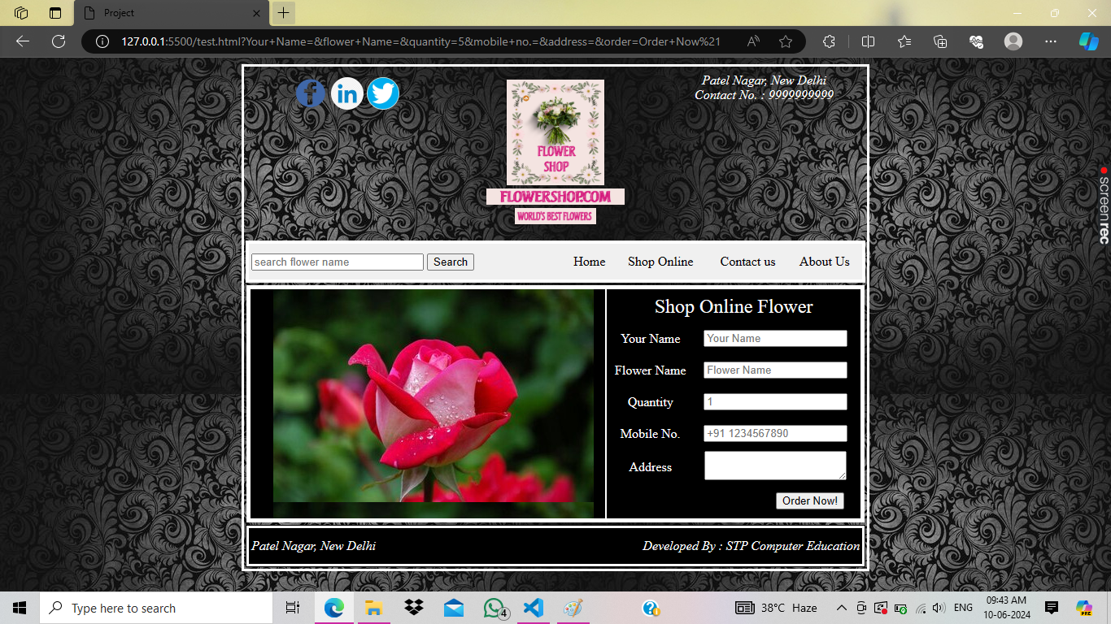</html>

**Attributes of <input> tag**

|  |  |
| --- | --- |
| **Attributes** | **Values** |
| type | Text, password, date, search, number, radio, checkbox, button, submit, color, email, website, file, hidden, image, reset, tel, week, month, range |
| name | Content name |
| placeholder | Insert any text for watermark |
| size | 30 |
| value | Use in special case |
| Max, maxlength | 12 |
| required | required |

<!DOCTYPE html>

<html>

  <head>

    <title>HTML Forms Methods and Actions</title>

  </head>

  <body>

    <form>

      Username<br />

      <input type="text" name="username" maxlength="10" required="required" />

      <br /><br />

      Password<br />

      <input

        type="password"

        name="password"

        maxlength="20"

        required="required"

      />

      <br /><br />

      Dob<br />

      <input type="date" name="dob" />

      <br /><br />

      Gender<br />

      <input type="radio" name="gender" value="male" required="required" />Male

      <input

        type="radio"

        name="gender"

        value="female"

        required="required"

      />Female <br /><br />

      Profile Pic<br />

      <input type="file" name="profile" accept=".jpg" required="required" />

      <br /><br />

      Choose Color<br />

      <input type="color" name="color" />

      <br /><br />

      Courses<br />

      <select name="course">

        <option value="Maths">Maths</option>

        <option value="Hindi">Hindi</option>

        <option value="English">English</option>

        <option value="Science">Science</option>

        <option value="SST">SST</option>

        <option value="Commerce">Commerce</option>

        <option value="Drawing">Drawing</option>

      </select>

      <select name="course">

        <option value="Maths">Maths</option>

        <option value="Hindi">Hindi</option>

        <option value="English">English</option>

        <option value="Science">Science</option>

        <option value="SST">SST</option>

        <option value="Commerce">Commerce</option>

        <option value="Drawing">Drawing</option>

      </select>

      <select name="course">

        <option value="Maths">Maths</option>

        <option value="Hindi">Hindi</option>

        <option value="English">English</option>

        <option value="Science">Science</option>

        <option value="SST">SST</option>

        <option value="Commerce">Commerce</option>

        <option value="Drawing">Drawing</option>

      </select>

      <br /><br />

      Enter Website Url<br />

      <input type="url" name="website url" />

      <input type="button" value="Click Here" name="button" />

      <br /><br />

      Mobile No.<br />

      <input name="mobile" type="tel" maxlength="10" />

      <br /><br />

      Range<br />

      <input type="range" min="0" max="13" />

      <br /><br />

      <input type="checkbox" value="i accept" />i accept <br /><br />

      <input type="reset" value="Reset" />

      <input type="submit" value="Login" />

    </form>

  </body>

</html>

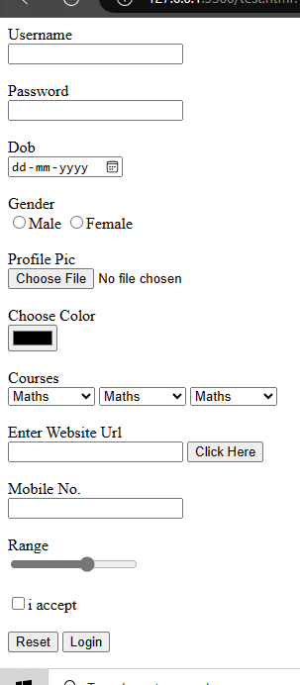

**Chapter – 26**

**HTML Entity**

**HTML Entity**

Characters that are not present on your keyboard can also be replaced by entities.

|  |  |  |  |
| --- | --- | --- | --- |
| **SYM** | DESCRIPTION | ENTITY NAME | ENTITY NUMBER |
|  | Non breaking spaces | &nbsp | &#160 |
| < | Less than | &it | &#60 |
| > | Greater than | &gt | &#62 |
| & | ampersand | &amp | &#38 |
| © | Copyright | &copy | &#169 |

Html Entity Symbols link

https://www.w3schools.com/html/html_charset.asp

<!DOCTYPE html>

<html>

  <head>

    <title>Html Entity</title>

  </head>

  <body>

    <h1><Priyanka></h1>

    <h1>&#60Priyanka&#62</h1>

  </body>

</html>